**Process for Constructing the Billboard Music Database**

The data for this project was retrieved from our sources as a comma separated value text file, which must be loaded into a PostgreSQL database for site access. This process documents the steps to build the database and load the data into it so that the website may function as intended.

1. Save the files **billboard_hot_100_1960_to_2018_with_lyrics_and_wordcount.csv** and **schema.sql** from the GitHub repository to the computer locally.
2. Start pgAdmin 4 and login as normal.
3. Create a new database *Billboard_Project* (Servers>PostgreSQL 11>Databases, right-click and select context menu option “Create >” and choose “Database.”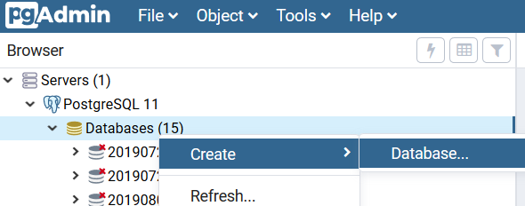
4. Highlighting the new *Billboard_Project* entry, open the Query Tool by clicking “Tools” and “Query Tool.”

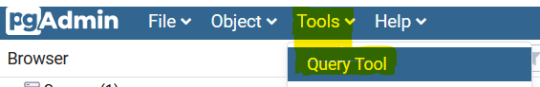

1. Open the schema.sql file in a text editor and paste it into the Query Tool, and execute it using the highlighted menu option.

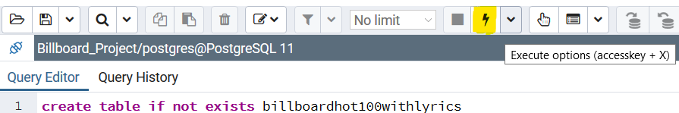

1. Expand the Tables list item if necessary and right-click *billboardhot100withlyrics* to select “Import/Export…”
2. On the menu that follows, change the Import/Export slider to “Import”, select the file **billboard_hot_100_1960_to_2018_with_lyrics_and_wordcount.csv** from where it was saved in step 1. Change the “Header slider to “Yes”, change the Delimiter dropdown to “,” (comma, without the double-quotes. Finally, change the Escape Character to “~” (tilde, without the double-quotes) so that the menu appears as in the two following illustrations:

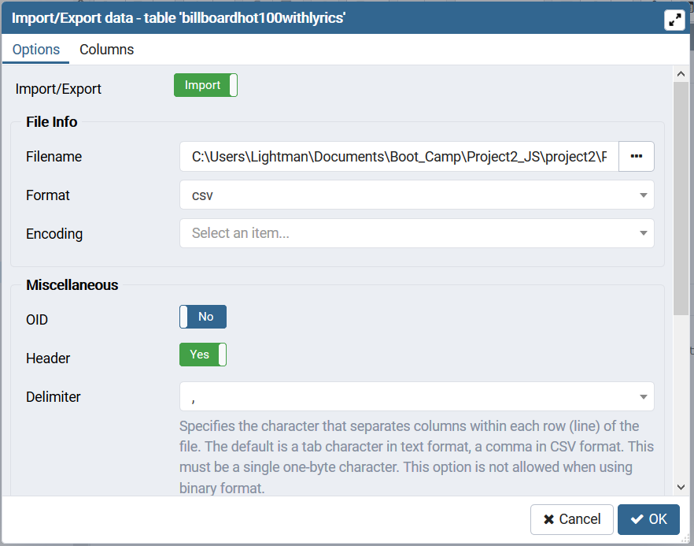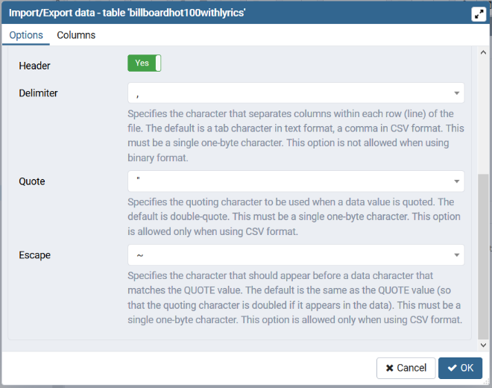

1. This concludes the database creation and data import process.